UNIVERSITY OF THE EAST

Rating
152 Samson Road, Caloocan City
College of Engineering
Information Technology Department

CCP1101 – COMPUTER PROGRAMMING 1
Laboratory Activity 11

Name |  | Section:
Student Number |  | Professor: | Celis, J. R. E.

INSTRUCTIONS:
- For each problem, paste the code and sample output here.
- Don’t forget to print your name at the end of the output.

EXAMPLE:

Sample Problem:

Create a Python program that accepts currency in Peso, and will display the equivalent in Dollar, Euro, and Yen.

Code: Sample Output:
import os;
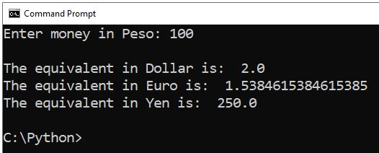
os.system('cls');

peso = int(input("Enter money in Peso: "));

dol = peso / 50;
eur = peso / 65;
yen = peso * 2.5;

print();
print("The equivalent in Dollar is: ", dol);
print("The equivalent in Euro is: ", eur);
print("The equivalent in Yen is: ", yen);

Problem 1:

Convert this Class Diagram into a C++ program.

